ACMSFF: A Campus Mapping System for Freshers

Pushpraj Roy  
*Department of Computer Science and Engineering*  
*Chandiarh University* Mohali, India  
pusprajraybirpur@gmail.com

Abhinandan Kumar  
*Department of Computer Science and Engineering*  
*Chandiarh University*Mohali, India

Arshdeep Kaur  
*Department of Computer Science and Engineering*  
*Chandiarh University*Mohali, India  
  
  
Abhishek Saxena  
*Department of Computer Science and Engineering*  
*Chandiarh University*Mohali, India

Madhur Sharma  
*Department of Computer Science and Engineering*  
*Chandiarh University*Mohali, India

Deepika Sharma  
*Department of Computer Science and Engineering*  
*Chandiarh University*Mohali, India

*Abstract*: This research paper presents a novel approach to designing and implementing a campus map tailored specifically for upcoming students. In the transition to university life, many freshers find navigating the expansive university grounds challenging. The unique features of the map aim to facilitate a smooth transition by providing a simple, user-friendly, and comprehensive digital map of the campus. The map incorporates building locations, routes, and accessible points of interest such as libraries, classrooms, cafeterias, parks, and recreational facilities. Additionally, the resource provides detailed information about each location and navigation features like direction guidance, distances, and time. Utilizing this tool, freshers can easily familiarize themselves with the campus, thereby enhancing their adaptability and overall, the university experience. Feedback gathered for ongoing improvements ensures that this campus map remains an invaluable tool for newcomers’ students.

Keywords—Interactive Maps, Student engagement, Navigations, User-friendly design, New Students, Feedback.

# **Introduction**

Commencing college is an exciting endeavour, but it can also be a complex maze of unfamiliar buildings, pathways, and resources. This is where "ACMSFF" steps in. We proudly introduce "ACMSFF". Your Freshman Campus Companion," a groundbreaking initiative aimed at ensuring a smooth transition into the captivating realm of university life. "ACMSFF" offers more than just a map; it serves as your personalized guide for navigating the academic labyrinth and uncovering the hidden treasures of your campus. As a freshman embarking on a journey of self-discovery and growth, we are here to assist you at every turn.

In this project, we have harnessed the capabilities of technology to craft an innovative website that will serve as your reliable partner throughout your freshman year. Whether you are searching for your next lecture hall, locating the finest study spots, or seeking information about campus clubs and events, "ACMSFF" has you covered. Our objective is straightforward: to equip you with the knowledge and tools required not only to survive but to thrive in your new academic environment. From real-time navigation to up-to-date event listings and insider insights, "ACMSFF" is your all-in-one resource for making the most of your time on campus.

However, "ACMSFF" is not merely a tool for physical navigation; it represents an entry point into a vibrant campus community. Connect with fellow freshmen, explore campus traditions, and stay informed about exciting opportunities—all at your fingertips. As you embark on this exhilarating phase of your life, remember that you are not alone. "ACMSFF" is here to guide you, support you, and enhance your university experience. Prepare to explore, learn, and flourish with the ultimate companion for freshmen -- welcome to "ACMSFF"

# **LITERATURE REVIEW**

In [1] The concept of campus maps for fresher Students in a college or university has a rich history. The first campus map was launched in the year 2011 on August 5 by the University of Maryland.Campus mapping system for freshers is a mobile navigation system or service that is available at 100 universities in the United States of America (US). The first campus map for freshers was released in 2011 for iOS users only.

In [2] campus maps were traditionally made on paper, offering students a visual depiction of the campus structure. However, over time, these static maps have undergone changes to include digital innovations, interactive elements, and live updates. This section examines the historical progression of campus maps, tracing their evolution into dynamic and easily accessible resources designed to assist new students. Numerous writers have recognized the significance of campus maps for newly enrolled students in colleges and universities. Some have also outlined the difficulties associated with converting these maps into digital formats. It is widely perceived that the shift from physical to digital campus maps is progressing at a relatively sluggish pace.

In [3] Several recent studies have been conducted in the field of application development, with a focus on creating mobile solutions that empower campus users to leverage the benefits of cutting-edge mobile technology, developed a mobile navigation application specifically tailored for the University of Calgary in Canada. This application was designed to provide users with location-based information by utilizing GPS-based positioning and a location tracking algorithm that relied on wireless network signals. This combination allowed the app to determine users' geographic positions even when they were inside buildings. The standout feature of this application was its user-friendly navigation tool, which could find paths on the campus for user-defined locations. Additionally, it offered indoor location tracking, enabling the app to pinpoint a user's exact location within a building and provide context-based information about their surroundings.

[4] However, it's worth noting that during the development of this application, the Android Software Development Kit (SDK) was still in the early stages of development. This meant that the developer community had limited access to the SDK's full range of system development features, potentially posing challenges for the project's development and optimization.

[5] At University of Ibadan in Nigeria developed a mobile appointment management system for the University, using the Android platform. This application made use of two Google Application Programming Interfaces (APIs), one for mapping and the other for calendaring. The rest of the application was coded in Java. The project yielded a fully functional mobile app designed to assist with appointment scheduling and management. Within the app, users input appointment details through a user-friendly interface. These details are then stored by the Appointment Manager App.

In [6] Subsequently, the app communicates the appointment's date or time to the Calendar API and conveys the appointment's location to the Map API. The Latitude API is responsible for acquiring user coordinates, which are then passed on to the Map API to display the corresponding map on the user interface. It's important to note that the Latitude API was not seamlessly integrated into the application. Consequently, it couldn't calculate the estimated travel time to reach an appointment's destination, as might have been initially envisioned, also developed a location-aware application that empowers users to pinpoint their own location and identify landmarks within the university campus for Bowen University Campus in Nigeria. The primary focus during the design of this system was on delivering a high level of simplicity, ensuring a quality user experience, creating an aesthetically pleasing user interface, and, most importantly, providing accurate data.

In [7] This project falls under the category of a Global Information System (GIS) application, which necessitates a device capable of detecting and recognizing location. The data source for this application was a GPS device, which collected positional information from GPS Satellites. While the application offered features such as place searches, the ability to check nearby landmarks, and access to brief descriptions of those landmarks, there were additional functionalities that could have been integrated. These included features like class timetables, event reminders, an academic calendar, and an automatic airplane mode setting during lecture times, has also created a Mobile University Student Guide (USG) for the Islamic University in Palestine. This application assists students in managing their university class schedules, organizing daily appointments on campus, and receiving notifications through alerts.

[8] However, it's important to note that the app does not include a map-based direction guide to locations within the university, which could have been particularly valuable for new students (Freshers) looking for their way around the campus.

# **MATERIALS AND METHODS**

College campuses have complex infrastructure because it is difficult to navigate and identify destinations, especially for new students and visitors. Sahibzada Ajit Singh Nagar (Mohali), Punjab is home to the Chandigarh University campus, spread over 250 acres, located on the NH-95 Chandigarh-Ludhiana highway. Many of the structures on this site are up to six stories tall. Most of these structures are far apart. Users do not always get help getting to their destination, although there are maps to various locations on campus.

On these static maps, they may try to find their way to their destination, but once they start moving in that direction, they will find themselves. So how can freshmen and other non-majors find their way around a college campus, and how can they get help using modern tools?

A 3D GIS model of the campus was selected, supplemented by layers for campus buildings and infrastructure. Mohali and the university's main campus are pictured in the satellite image. One of the private institutions in Mohali is Chandigarh University. It has gardens, parks, sports fields, classrooms, buildings, and gates.

The following processes are included in this study's 3D model of the university campus and its implementation in the campus information system:

· Collect data.

· Create 3D models.

· Visualize 3D models.

The following section contains more information about this job. Layers in an existing GIS system are collections of features arranged in a shape file, an object. Various vector classes were available for this investigation from the engineering and computer science departments on campus.

These layers include building, road, and utility layers.

• The CAD format data in the figure are AutoCAD files.

• Files from building plans and area maps are digitized as well as Google Earth images of the desired location.

• Database of attribute information and accompanying documents.

The main thematic data layers of these GIS include information about campuses, buildings, roads, water systems, and telephone networks. These classes must generate the location and attribute data necessary to perform collection and management functions.

A 3D model of the main campus was constructed for this Project. CAD drawings of the Faculty of Computer Science and Engineering building were obtained during the early stages of the investigation. Measurements and data collection are used to create the necessary 2D and 3D GIS information systems.

Georeferencing maps are created in this process using GCPs (Ground Control Points) collected for the campus area using GPS (1-2m accuracy). The general method stages are shown visually. This image illustrates the six stages of this method.

The Department of Computer Science and Engineering, Chandigarh University served as the primary source of information for creating 3D GIS models for the university using paper maps and AutoCAD (CAD format). This application has three parts. Figure illustrates how to use 2D GIS to explore campus planning information, select target locations, and determine simulation parameters. To describe the current state of the campus and the analysis results, 3D GIS is used.

**ArcGIS (version 9.2):**

Geographic information system “GIS” is a tool used to map, store and analyse geographic data. Any type of information related to a location is stored in this system. Spatial components are stored in a coordinate system that refers to a specific location on the Earth's surface.

Geographic information systems are mainly used for resource management, development planning, and academic research. The most important program in GIS applications is ArcGIS. Today, virtual reality software is supported by ArcGIS.

ArcGIS supports all types of data, including any statistical data that needs to be combined with features and stored in a database. ArcScene and ArcGlobe can also be considered a type of virtual reality software (with some limitations).

After completing the 3D design of the university campus using ArcCatalog, the next step is to create a 3D model in ArcScene. A separate feature dataset and geodatabase were created. layers have been added to the new ArcScene file, such as roads, buildings, trees, etc. The 3D model of the other building is also available for use in ArcGIS. Floor numbers and 3D symbols such as trees and cars were used to add realism to the campus construction.Users can explore different building types and campus layouts, similar to a 2D perspective.Users can view different building types, campus planning data, and 3D views of green spaces in the 3D view, just as they do in the 2D view. ArcScene was used to illustrate multiple layers of the 3D university model.

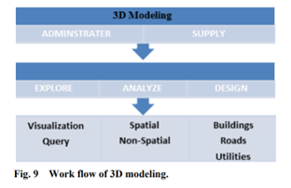

**Fig-1**

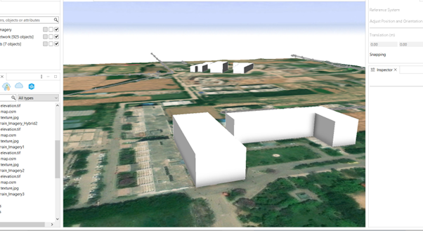

**Fig-2**

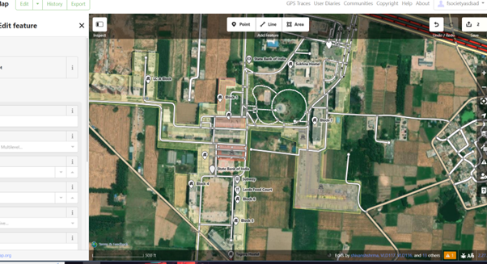

**Fig-3**

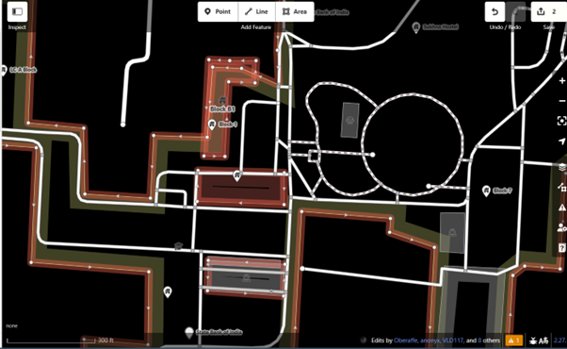

**Fig-4**

# **Result**

Our study followed a specific plan outlined in Figure to evaluate the effectiveness of campus mao application. To gauge the impact of this application, we conducted a survey involving 200 third-year engineering students. These individuals underwent a pretest designed to assess their knowledge of software engineering courses, consisting of 10 questions with varying levels of difficulty. After a period of 4 weeks following the administration of the pretest, we administered a post-test to gauge the current knowledge of the students. This post-test also comprised 10 questions, with each question carrying 2 marks, and no penalties for incorrect answers.

We employed a statistical method known as a t-test to compare the scores obtained from the pretest and post-test. The resulting analysis revealed a remarkably low p-value of 0.000, signifying a substantial disparity between the pre-test and post-test scores.

In summary, the descriptive statistics presented in Table 1 reinforce our findings, as they indicate that the mean scores for the pre-test were noticeably lower than those for the post-test. This compelling evidence suggests that the utilization of the campus map application had a significant and positive impact on the academic performance of the students.

|  |  |  |
| --- | --- | --- |
| **Group** | **Pre-test** | **Post-test** |
| **Mean** | **3.6** | **6.17** |
| **SD** | **1.79** | **1.16** |
| **SEM** | **0.21** | **0.12** |
| **N** | **200** | **200** |

*Table 1: Survey Data Count*

**Survey Questionnaire:**

To gauge the effectiveness of the "ACMSFF" system, we conducted a field evaluation based on survey responses. Our primary objective was to assess the quality and relevance of the recommendations generated by the system, as well as to gain insights into how students perceive and interact with the application.

To collect feedback and insights, we designed a survey that included a single open-ended qualitative question and an additional set of four questions aimed at gathering specific feedback. These questions were carefully crafted to elicit valuable insights and opinions from the survey participants.

Q 1: *How was the impact of the app on the user for finding location ?*

Students were to state how impactful the app was on their Campus Maps speed on a scale of 1-5. The scales denote 1: very bad 2: bad 3: average 4: good 5: very good.

Q 2: *How efficient is the speed of the app?*

Students were to state how helpful the app was for using Campus Map on a scale of 1-5. The scales denote 1: very bad 2: bad 3: average 4: good 5: very good.

Q 3: *Is the UI of the app easy to use?*

Students were to state the difficulty in using the app on a scale of 1-5. The scales denote 1: very bad 2: bad 3: average 4: good 5: very good

Q 4: *How likely is it for you to use this app in the future?*

Students were to state their willingness to use this app in the future on a scale of 1-5.The scales denote 1: very bad 2: bad 3: average 4: good 5: very good.

Q 5: *Write your experience while using this app.*

The initial four questions inquired about the efficacy of "ACMSFF" when applied to sample datasets, serving as an assessment of its performance. The fifth and final question, however, delved into students' perceptions of the application when they used it with their own datasets, aiming to understand their individual experiences and view points.

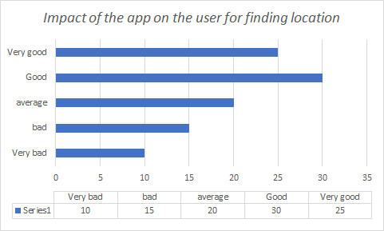

*Figure 6: The impact of the app on the user for finding location.*

In Figure 7, you can observe the distribution of responses pertaining to the second question in our survey.

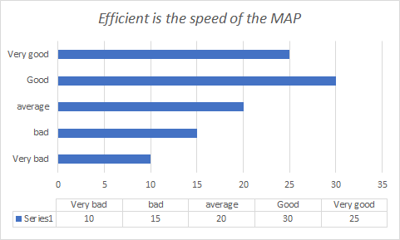

*Figure 7: Distribution of responses for efficiency of Campus Map*

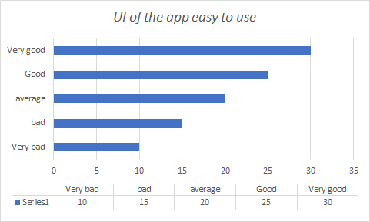Likewise, you can examine the responses to question 3, as visualized in Figure 8. This particular question inquired about the students' level of ease when utilizing the application. In line with the graphical representation in

*Figure 8: Distribution of responses for ease of use*

At last, we wanted to know whether the students would use the application in future or not. This question was answered by 4 % of the students in a negative response, as it is shown in figure 11. All others found it useful and they responded in other categories indicating willingness to use the application in near future.

# **Conclusion**

Campus maps in aiding freshmen to smoothly integrate into the university or college setting. With several advanced technologies and methodologies, user-friendly and effective maps can be designed. These maps significantly impact freshmen's engagement, confidence, and overall campus experience. Educational institutions should continue investing in novel mapping solutions to ensure successful student integration into campus life. Future research in this field could examine the efficacy of various map formats and technologies in facilitating freshmen's adaptation to their new environment. Such studies could provide insights for educational institutions on enhancing their supportive infrastructure for incoming students.

# **References**

[1] Beasley, P. (2010) “Interactive Map Can Help Find

Quickest Way To Class, Grad Student Asking For

Help In Testing Effectiveness”. Retrievedfebruary

09, 2014<Pnbeasley.Weebly.Com/Uploads/8/9/7/5/897

5782/Interactive_Map.Pdf>.

[2] Lautenschlayer, B. (2012). Design & Implementation of a Campus Navigation Application with Augmented Reality for Smartphones. University of Calgary. Department of Computer Science, Alberta Canada.

[3] Osunade, O., Osho, A., & Oyebamiji, S., (2014). Android appointment manager application development with Google APIs. Transnational Journal of science & Technology. 4(2) 80-92

[4] Akinwunmi, A., Aworinde, H., & Adewale, M., (2016). Development of a Mobile Location-Aware Campus Map Application. British Journal of Mathematics & Computer

Science 15(3) 1-9.

[5] Naser, S., Dawond, A., & Ali, K., (2016). Design and Development of Mobile University Student Guide. Journal of Multidisciplinary Engineering Science Studies 2(1), 193- 197.

[6] Little, R. (2013). “16 Inspiring Examples Of Interactive

Maps In Web Design”, Retrieved February 10, 2014

From <Http://Webdesignledger.Com/Inspiration/16-

Inspiring-Examples-Of-Interactive-Maps-In-WebDesign>.

[7] Karpilo, J. (2010). “What Is A Map”. Retrieved

February09,2014<Http://Geography.About.Com/Od/Understandmaps/A/Whatisamap.Htm>.